A very small and simple desktop program for xml text edit

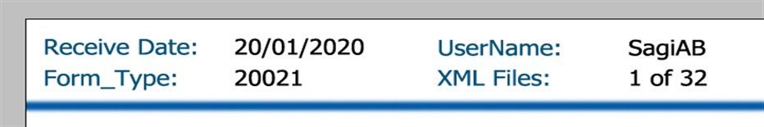Let you browse for source and target folders (will remember the path from last use)  
After source folder is selected the first file from the folder will be selected (FIFO) and the header will be filled   
  
From the XML “<Process_properties>”   
  
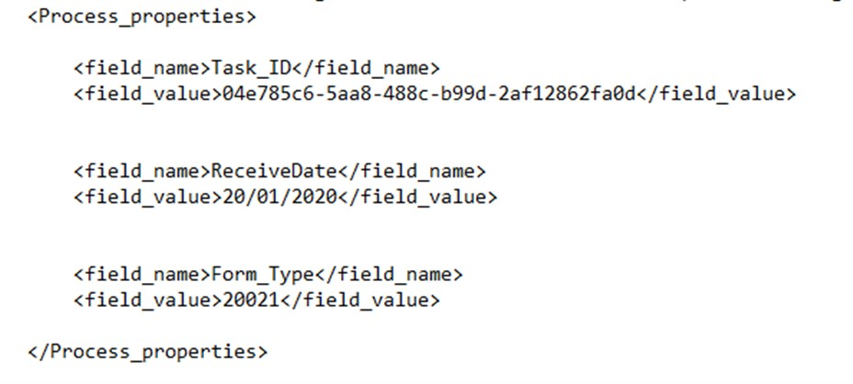  
  
and the username (preferred from the compute name if possible) or editable field to be filled.

The rest of the information from the file, will be load to a grid on the window (with scroll. The header will stay in fixed position).

The “Name” value will be read only title with the value editable.  
  
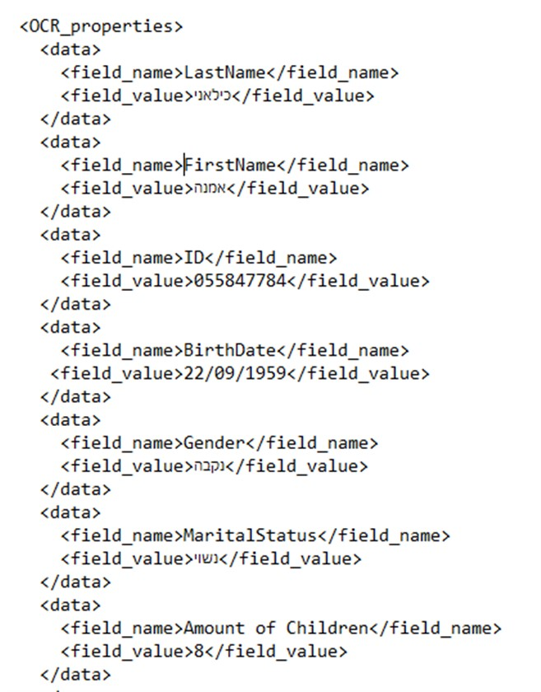

The grid is right to left (Hebrew) and if the field_name is in A Columb the value in B columb will be use (only on screen. File field_name will stay the same) if not, the original field_name will be in use.  
If Mandatory is check, it cannot be saved and a prompt and focus will be made.

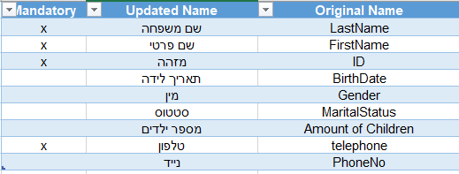

If one of the values in the grid contain one of the char in cell E2 ( (<?~,!) ) the grid cell of this value will be change background (or any other idea you got so the person looking on the grid will easily find those values).

If enter is hit, the cursoe move to the next value and select it to replace it easily

In the header there will be two buttons   
"**Save and next**". This will:

1. Create (if not exist) a subfolder in the source name original and copy the original file into it.
2. Add another data tag (if not exist) to with the user name. if exist, update the value  
   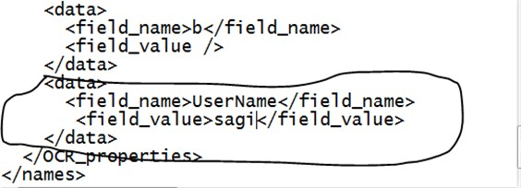
3. Save the file in the same text format to the destination folder and delete it from the source
4. Load the next file if exist

"**Skip**". This will:

1. Leave the file untouched and move to the next file